Energy Manager SWARM Technical Reference Guide

Contents

How SWARM Works 3

At the building level: 3

A. Internet Programmable Thermostats 3

B. HVAC Units 4

C. Economizer Controller (Recommended if economizer is available) 4

D. Wireless Gateway 5

E. Ethernet Port (Recommended connection for gateway) 6

F. Electricity Meter (Only needed if utility data is not available for the building) 6

In the cloud 7

G. Private VLAN (Recommended) / Campus Network / Cellular Network 7

H. Cloud Server 8

I. Thermostat Control 8

J. Thermostat Schedules 9

K. Building History 11

L. User Access 12

Getting SWARM Started on Your Campus 13

Identifying SWARM Buildings 13

Budget 14

Equipment Cost Breakdown 14

Stakeholders 15

SWARM Team 15

Campus Administration 15

Facilities Management 15

IT Team 16

Building Management & Occupants 16

Setting Up a SWARM Building 17

Determine SWARM Eligibility 17

Collect Information on Site 17

Order and Connect Equipment 18

Install Equipment and Assign Access 18

Holiday Shutdowns 18

Tracking Energy Savings 19

Measurement & Verification 19

Buildings with Baseline Interval Energy Data 19

Buildings with no Baseline Data 21

# How SWARM Works

At UC Davis, SWARM uses a Pelican Wireless cloud server to monitor and control HVAC systems through internet programmable thermostats.

## At the building level:

**To Cloud**

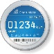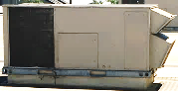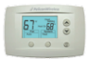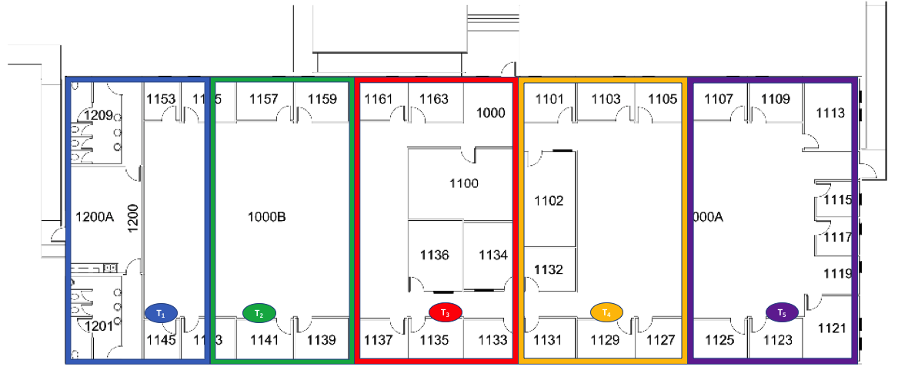

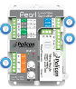

### Internet Programmable Thermostats

Installed at UC Davis: Pelican TS200/250;

* Installed in place of existing thermostats
  + No new thermostats added or zones created
  + Possible to add a remote thermostat to track temperature and balance conditioning within a zone for zones that are too big or improperly balanced
* Schedule is determined by occupant and set by SWARM team
  + Physical thermostat interface can be locked if in a more public space like lecture hall or unlocked if in a space like an office
  + If unlocked, the schedule can be overridden by occupants for a few hours
  + Building manager can create events to deviate from schedule
* Thermostats can communicate with the gateway (D.) and other thermostats
  + Gateway can reach thermostats up to 300 feet, but usually ends up being 200 feet or less when factoring in walls and enclosures
  + Thermostats can reach other thermostats from around 30 feet away
  + Thermostats that are connected to the gateway can connect thermostats that are out of reach by acting as a waypoint
* If the AC unit connected to the thermostat has an economizer with a controller (C.), a CO2-enabled thermostat can be added to receive a rebate from the utility

### HVAC Units

* The thermostats record data from the units and send it to the cloud
  + This includes the fan, heat circuit, compressor, and economizer (if applicable)
* The units can be controlled remotely using the web interface
  + Troubleshooting is easier for the HVAC techs
* See Figure 1 for one example of how the thermostat is connected to the HVAC unit

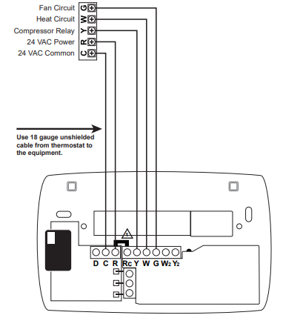

Figure : Sample Thermostat Wiring Diagram

### Economizer Controller (Recommended if economizer is available)

Installed at UC Davis: Pelican PEARL Economizer and Demand Ventilation Controller

* If the HVAC unit has an economizer, control and monitor with an economizer controller
  + This ensures that the economizer is actually working and allows for more efficient HVAC use
  + Make sure the unit is controlled by a CO2 sensing thermostat to receive a rebate for demand ventilation control
* See Figure 2 for an example of how the economizer controller is hooked up to the HVAC system and the thermostat.

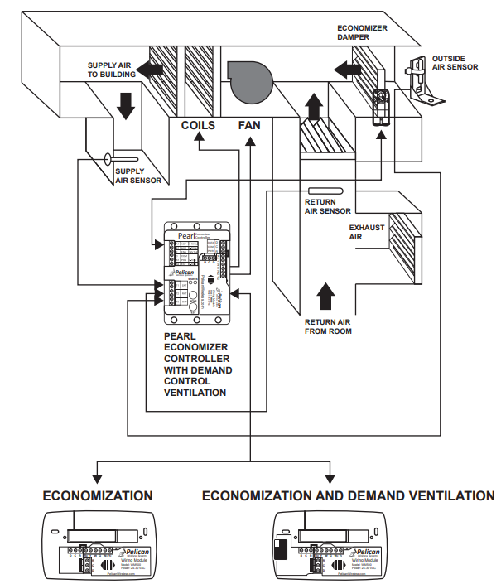

Figure : Sample Economizer Controller Diagram

### Wireless Gateway

Installed at UC Davis: Pelican GW400 Ethernet Gateway, Pelican GW400-LTE Cellular Gateway

* Gateway acts as a bridge between the building and the cloud-based database and web interface
  + No data is stored at this point, only transferred
* The Pelican gateways do not use the same bandwidth as the WiFi network, meaning that they do not interfere and cannot be interfered with the WiFi network
* There are different options for how the gateway connects to the cloud:
  + It can connect to an Ethernet port (E.) and from there either:
    - Through the general campus network to the cloud server
    - Through a virtual LAN (VLAN) specifically set up with a private address for SWARM use
      * In this case, the gateway must be assigned a static IP address via Pelican that is used to connect with the cloud
  + Alternatively, the gateway can communicate through a cellular network to the cloud server
    - This is often more expensive, but it is a good option if there is no access to a wired Ethernet port or if your IT team does not want the thermostats connected to the campus network or a VLAN
* The gateway and the Ethernet port are housed in a place that requires a key to access
  + This can either be inside an IT or maintenance closet or, if the building is not equipped with one of those, inside of an enclosure specifically installed for the SWARM project
  + Ideally, the location of the gateway will be close to any IT and telecom equipment in the building so that the Ethernet port is easy to install
  + It should not be located near any large metal structures if possible; this will interfere with the wireless communication.

### Ethernet Port (Recommended connection for gateway)

* If using an Ethernet-enabled wireless gateway, an Ethernet port will most likely have to be installed, especially if the gateway is connecting to the cloud server over a private VLAN
  + This will be done through the IT department, who will need to know the location of the desired port and the network you want to connect the gateway to

### Electricity Meter (Only needed if utility data is not available for the building)

Installed at UC Davis: eGuage Core + Current Transformer

* If the building does not have a specific electricity meter or you do not have access to the building’s meter data, an electricity meter will be installed
  + Allows for energy tracking to determine program energy and cost savings which is crucial for budgeting reasons
* The meter sends electricity use information to an online database and is connected to current transformers that measure the electricity going through a circuit
* Connected to a separate VLAN from the wireless gateway
  + If the HVAC units are all fed by the same panel, then each circuit going to the individual units should be measured
  + If there are multiple units serviced by multiple panels in different locations, just measure the current for the main electric line for the building as shown in Figure 3

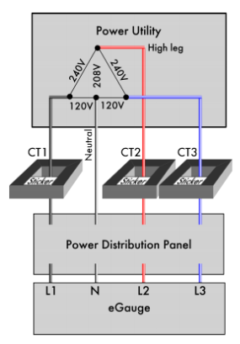

Figure : Sample Electric Meter Setup

## In the cloud

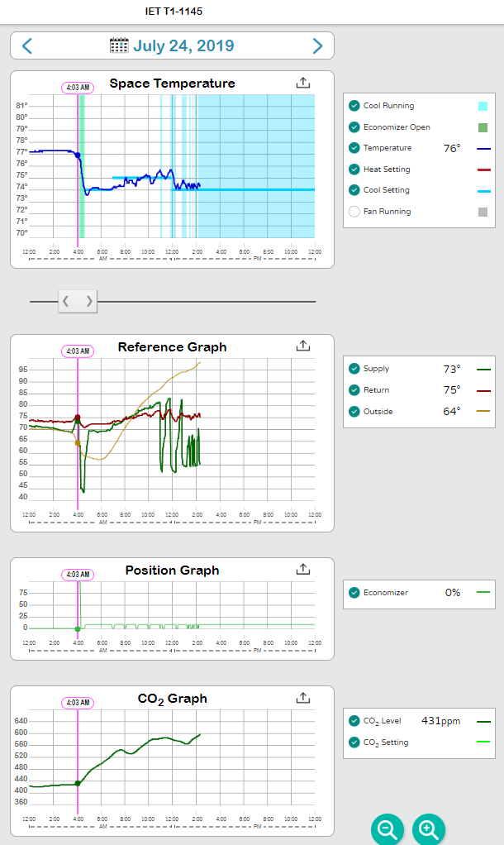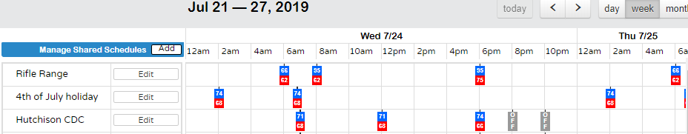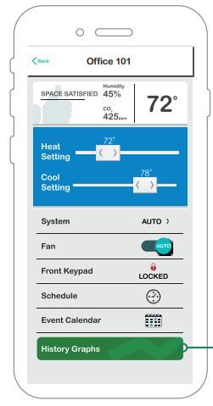

**To Building**

**Private VLAN**

### Private VLAN (Recommended) / Campus Network / Cellular Network

* The most secure way to transfer information from the buildings to the cloud server is through a private virtual LAN (VLAN) that is specifically used for SWARM
* If there was an electric meter installed for the SWARM project, it will be on a separate VLAN from the thermostats
* The VLAN is created and operated by the campus IT team.
  + The client used for the cloud server and thermometers (Pelican for UC Davis) will be given access to the VLAN to connect to the cloud server

### Cloud Server

Used at UC Davis: Pelican Wireless

* All readings from the thermostats are sent to a central database where they are compiled and stored so that they can be accessed at a later point
* The VLAN or other network connection connects the cloud to the building data, and it is accessed via a unique website URL assigned by the cloud client (Pelican for UC Davis)

### Thermostat Control

Used at UC Davis: Pelican Wireless

* To view the readings from the thermostat and status of the HVAC equipment:
  + Access the specific, secure URL provided by the cloud server client
  + On the dashboard, you can view any building in the SWARM system that you have installed the thermostats in
  + See Figure 4 for an example

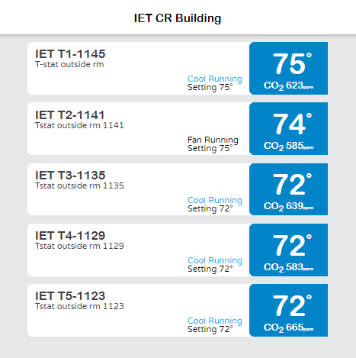

Figure : Sample Building Dashboard

* Within each individual thermostat, you can:
  + See the temperature in the space and, if the thermostat is CO2 sensing, the CO2 level
  + Adjust the set points, fan settings, physical keypad access, which schedule to run, and economizer status, as shown in Figure 5
  + These views are useful for HVAC technicians trying to troubleshoot the system and a building manager interested in changing the set points
  + From this view, it also possible to create a new event (J.)

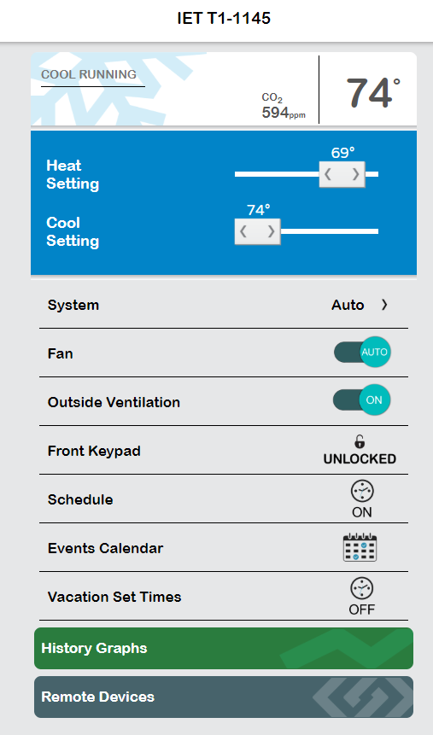

Figure : Sample Thermostat Dashboard

### Thermostat Schedules

* A main feature of the SWARM program is programming building HVAC use around a set schedule
  + Schedule is determined by the building manager
  + SWARM can create a different schedule for the weekend than the week, as shown in Figure 6

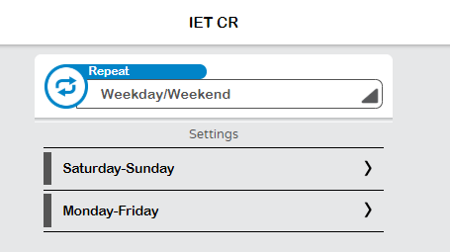

Figure : Sample Building Schedule Page – Week

* Within the day view of the schedule, the building can perform an “optimum start” which means that the building will ramp up prior to occupancy
  + On this page, you can adjust the set points for different times of the day.

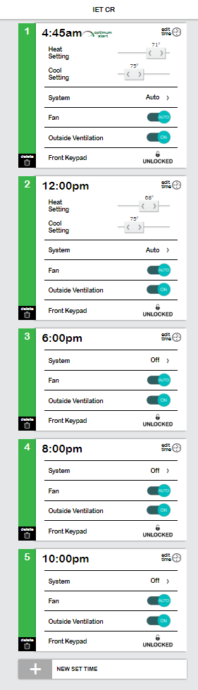

Figure : Sample Building Schedule Page – Day

* For special events that will require a deviation from the normal schedule:
  + Schedule an event by going to “Events Calendar” on the Thermostat Dashboard (see Figure 5)
  + Adjust any set points or equipment necessary for the event
  + This is what building managers will use when adjusting the schedule for a specific time period

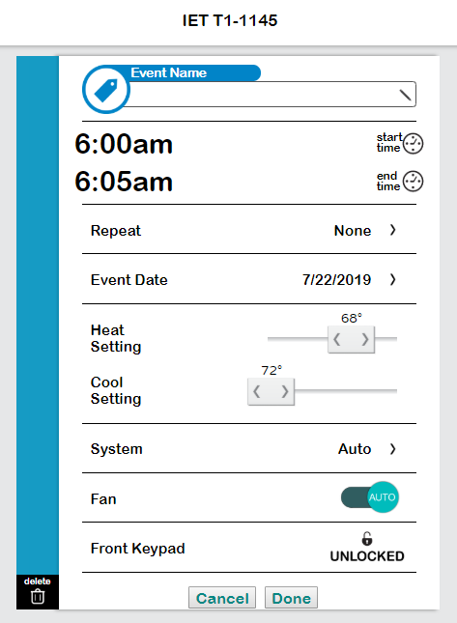

Figure : New Event Creation

* To view the set point schedule of all buildings and thermometers in the system, view the Schedule Dashboard
  + Create events and edit any building or thermometer schedule



Figure : SWARM System Schedule Dashboard

### Building History

Used at UC Davis: Pelican Wireless

* To troubleshoot the HVAC system, review cold and hot calls, and view equipment statuses in general:
  + View the “History Graphs” from the Thermostat Dashboard (see Figure 5)
  + By scrolling through the day, you can observe when the fans were running, when the cooling or heating unit was running, when and how much the economizer was open (if applicable), and compare outdoor, supply, and return temperatures
  + This is the main page that the HVAC technicians will want to look at when troubleshooting a system



Figure : SWARM History Graphs

### User Access

* Two types of access: User and Admin
  + Admins are typically energy managers, anyone working on the SWARM program, and HVAC technicians
  + Admins can see all history graphs, adjust any schedule or set point, and add buildings or thermostats
  + Users are typically building managers who only need to access the thermostats of their building
  + Users can only see the Thermostat Dashboard for their thermostats
  + To add a new user, just assign them a username and give them access to specific thermostats (see Figure 11)

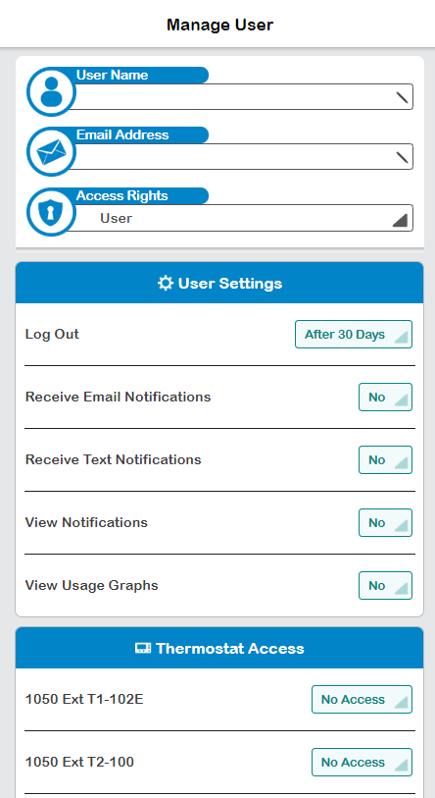

Figure : New User Page

# Getting SWARM Started on Your Campus

## Identifying SWARM Buildings

* Start to identify potential SWARM buildings on your campus
  + Begin by finding as many buildings as you can that are not connected to the central building automation system
  + Small buildings, temporary classrooms or offices, or buildings somewhat isolated from the rest of campus are usually good candidates
* Try to group any of these potential SWARM buildings by proximity
  + If there are a number of them clustered together, it is possible to use a single gateway for all of them which is more cost effective
* Finally, identify just a few buildings from the list to use for a pilot program that fit most, if not all, of these criteria:
  + Metered, with access to utility data history spanning at least one year
  + Has flexible HVAC requirements; offices & classrooms are better than labs because temperature does not need to be consistent 24/7
  + HVAC units have economizers
  + Does not use natural gas for heating
  + Relatively large energy footprint compared to other identified buildings

## Budget

* Using the provided Excel spreadsheet, “SWARM Toolkit Budget Estimate”, begin to estimate the cost of implementing the pilot program
  + On the “Itemized Budget” sheet, add your first few buildings and answer the questions to guide the potential implementation costs of the building

Table : Budget Information Input



* The estimated costs are based on the SWARM program at UC Davis
  + If using the same equipment as UC Davis’s SWARM program, these costs should be the same, but labor costs may vary and the necessary equipment will vary by building

Table : Estimated Itemized Costs



### Equipment Cost Breakdown

* The new thermostats will be a 1:1 replacement of the existing thermostats
  + If the HVAC units have economizers, we recommend getting CO2 sensing thermostats, economizer controllers, and actuators for the economizers so that the building is eligible for larger rebates
* Each building will need one gateway unless there is a cluster of buildings that has thermostats within ~25 feet of each other between buildings
  + If the building is very spread out and thermostats cannot reach each other or the gateway, a repeater may be necessary
* If there is no convenient, secure maintenance or IT closet for housing the gateway and Ethernet port, an enclosure will need to be installed. This enclosure cannot be metal.
* If there is not an electricity meter installed on the building, one may have to be purchased if utility metering is desired
  + It should be able to connect to a central database, similar to the thermostats
  + It will be sufficient to purchase a small meter (instead of PG&E installing one) and connect it to multiple CTs
    - Size these based on the size of the transmission line you intend to monitor

## Stakeholders

### SWARM Team

* It helps to have a team of a few students or staff under the energy manager who spend most of their time on SWARM implementation
  + We have found success with either a graduate student or full-time staff member running the day-to-day operation of SWARM while the energy manager or other energy and engineering team leader oversees the broader direction of SWARM
  + Additionally, we have found it helpful to have part-time undergraduate interns to help out with the site visits, getting the equipment set up, and putting in work orders
  + This team will hopefully grow with SWARM on your campus, but initially it is helpful to at least have one other staff member or student working on SWARM besides the energy manager

### Campus Administration

* The first group of stakeholders to present the plan for your SWARM program to is the campus administration
* After developing your budget, create a timeline for implementing the pilot SWARM program and a presentation of the broad overview of SWARM
  + This can be very similar to the Campus Energy Module slide deck, with minor editing to the Next Steps section
  + The key points to focus on are that the program can have a reasonable payback period, it can make life easier and safer for the HVAC team, and can reveal temperature history in isolated buildings around campus

### Facilities Management

* The facilities team will be the group of stakeholders with the most day to day interaction with SWARM, especially the HVAC team
  + First, the SWARM team will put in work orders to facilities management for the installation of the thermostats
  + After everything is in place and set up, the HVAC team will monitor the remote equipment data for any potential issues such as a system running 24/7 or not at all
  + Additionally, they will use data from SWARM when responding to cold or hot calls by building occupants
* It is crucial for the facilities team to understand the benefits from SWARM relating to equipment maintenance and building temperature history
  + We suggest presenting our Facilities Management Module to the facilities team as soon as possible and providing training on best practices and helpful tips for interacting with the web interface
  + This will hopefully help increase their engagement with and enthusiasm for SWARM

### IT Team

* The IT team may be the stakeholder with the most concerns around SWARM and the most potential to slow the SWARM process down
  + The most effective way for SWARM to connect building thermostats to the web database is through a VLAN that must be set up by the campus IT admin
  + The Communication Resources team will be the ones installing the Ethernet ports in the building to allow the gateways to connect to the VLAN
* The campus IT admin will most likely have security concerns about the SWARM program and the way the technology interacts with each other, the campus network, and the external cloud client
  + We suggest presenting our IT Administrators Module to the IT team to help address concerns
  + If you choose to opt for technology other than the Pelican equipment and web client that we use in the UC Davis SWARM program, it is important to address the same concerns noted in the module

### Building Management & Occupants

* The building manager will be the main point of contact for the building when the SWARM team is coming on site or determining the schedule for the building
  + They will have access to the remote thermostat controls for the building
  + They will also have the ability to create special events to deviate from the scheduled set points in the space
* When developing the SWARM program, it will be important to identify the appropriate building manager for each of the buildings being considered for the pilot program and contact them with information on SWARM and how it will affect their building
  + We will provide communication templates in our Building Manager Module
  + The most important talking point is that one of the program’s main goals is to increase comfort in the space and make sure that the building is meeting the air conditioning needs of the space
* The building occupants will most likely being the ones making cold and hot calls to the maintenance team
  + They will be more convinced of the efficacy of the HVAC system if the HVAC team can show them temperature history and equipment status data as proof of either responses to the cold and hot calls or the lack of need for a response

# Setting Up a SWARM Building

## Determine SWARM Eligibility

* After creating a list of potential SWARM buildings for your pilot program in your initial audit (see Identifying SWARM Buildings), the next step will be determining and contacting the building managers
  + You will want to set up a site visit, ideally with the building manager present to show you around
  + It will be helpful to bring a floorplan, mechanical drawings if you can acquire them, and perhaps a list of standard questions for the building manager about the current conditions of the heating and cooling of the space
* There is no set criteria for what makes a building eligible for SWARM, but ideally the building will have a good amount of energy savings opportunities
  + This might mean that the HVAC system is running 24/7 or that the thermostats do not have any set schedule
  + For the first few buildings in the pilot program, it will be helpful if the building has a locked electrical or IT closet that the gateway and Ethernet port can be installed in so that you do not have to spend money on an enclosure and so that the Ethernet port is close to the rest of the IT equipment in the building, making it easier and cheaper for the communication resources team to install the Ethernet port
  + Finally, the HVAC team should be included in the decision about SWARM eligibility
    - There may be units or economizers on the building that the HVAC team sees as areas of potential savings, either for energy or maintenance time, that the SWARM team was not able to identify on their initial visit

## Collect Information on Site

* Ideally, the buildings you’ve chosen for the SWARM pilot program have meters for interval data
  + This will provide you with the baseline data necessary for measuring the savings of the SWARM program, which will be crucial for showing the value of the program
  + If this is not the case or you do not have access to this data for some reason, there are a few alternative options for collecting baseline energy data:
    - One is to install an energy meter at the site (this can simply consist of an energy logger and a few current transformers) and log HVAC runtime data prior to SWARM installation for at least a month to understand use
    - Another option is to make an estimate about the previous schedule of the building using either observations from your site visit or perhaps occupancy loggers, if available
  + With this data, combined with the tons of heating and cooling controlled by the thermostats, you can estimate the energy use for the HVAC system in the building
* Note the number and location of thermostats in the building so that you can replace them with the new wireless enabled thermostats
* Locate the intended location of the gateway and Ethernet port.
  + IT closet is ideal
  + If the building is spread out or you are working on implementing a cluster of buildings into SWARM, you will want to measure the distance between the gateway and the thermostats
    - Pelican gateways can usually connect to thermostats 250-300 feet away unobstructed, but this is more like 150-200 with a wall or two in the way
    - The thermostats can connect to each other from a range of about 30 feet
    - If there is a thermostat farther than connecting-distance of either the gateway or a connected thermostat, you will need to install a repeater.

## Order and Connect Equipment

* After the VLAN is set up by IT, request that the communication resources team install an Ethernet port that connects to the VLAN
  + Provide them with a floor map and photo indicating the exact location on the wall to install the port, along with the VLAN network
* Order the equipment necessary for the building
  + Enough thermostats to replace all the existing thermostats in the building
  + One gateway
  + Any repeaters necessary
  + If the building has economizers on the HVAC units, purchase economizer controllers for each unit and make sure that the thermostats connected to these units have CO2 sensors so that you can apply for the full PG&E rebate
* Set it up and test it before installing it in the field
  + Plug the gateway in and connect it to the SWARM network by creating a new gateway on the web interface using the serial number on the gateway
  + Turn on the thermostats and connect them to the gateway
    - Assign them the desired name and schedule on the SWARM website

## Install Equipment and Assign Access

* Take the gateway out to the building and connect it to the port
  + Make sure that the building shows up on the SWARM website before leaving
  + Put in a work order to the facilities team to install the thermostats and the economizer controllers if applicable
  + Finally, make sure that the thermostats are live and visible on the SWARM website.
* Give access to the remote thermostat control to the building manager(s)
  + At this point, run them through the part of the Building Manager Module that describes how to use SWARM in their building and make sure they are comfortable with the controls and event scheduling
* At this point, the building should be ready for monitoring and tracking

# Holiday Shutdowns

* Shutting down buildings on holidays can be an easy way to save energy using SWARM
  + Send out emails to each building manager in SWARM prior to a holiday asking if the building will be occupied
  + Create a holiday event (see Thermostat Schedules) on the schedule dashboard that shuts off the HVAC system for each unoccupied building
  + If the building user indicates that the building will be occupied, do not adjust the schedule in that space